1 | 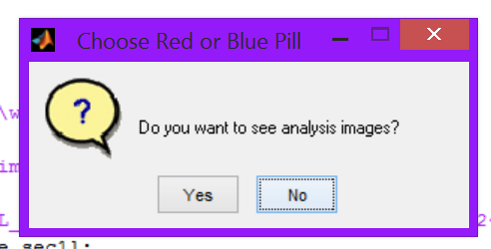 | Click “No” to increase speed
2 | 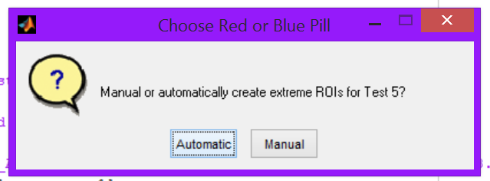 | Automatic QA for PIU is available
3 | 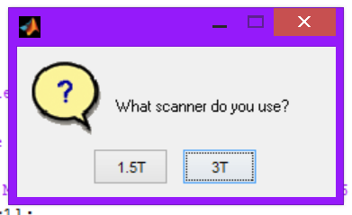 | Select your scanner field strength
4 |  | Log and images are save to designated directory

