1 | 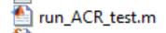 | Run the run_ACR_test.m script
2 | 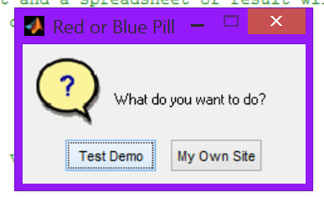 | Choose “Test Demo” if you want to perform on the demo images. Choose “My Own Site” if you want to do QA on your site’s image
3 | 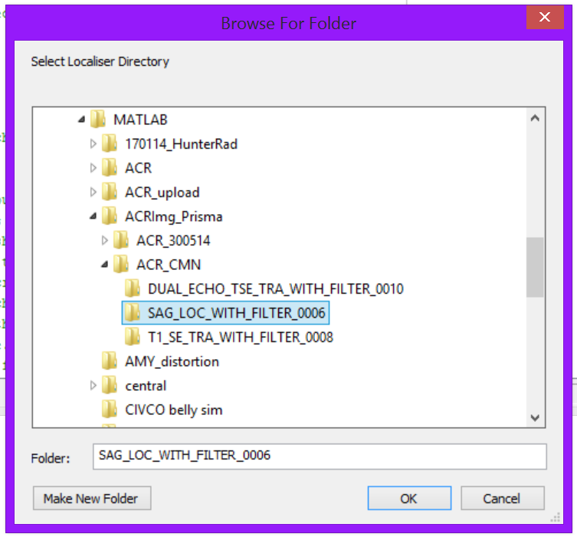 | If you chose “My Own Site”, you will need to select the directories of localizer, T1 and T2 images.  Please note that ACR recommended T2 image was dual echo with 22 images in total. You don’t need to delete the first 11 images, the program can detect the right images to use by itself.
4 | 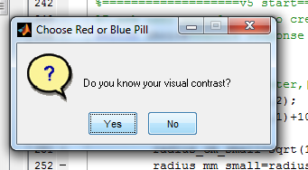 | User’s visual contrast on that particular monitor
5 | 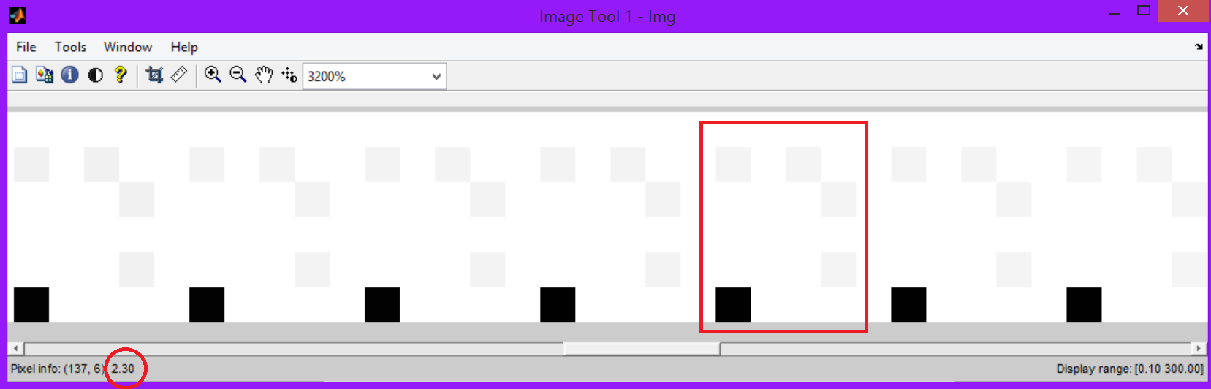 | To test the contrast sensitivity, find the pixel pair with lowest contrast that you can identify. The contrast (in %) is given by the dark pixel at bottom left corner
6 | 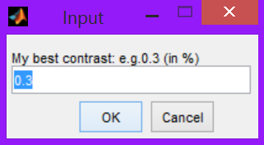 | Enter the contrast value shown in previous window
7 | 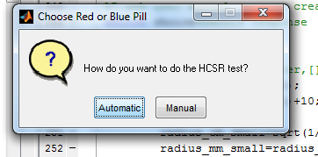 | Automatic HCSR (high contrast spatial resolution) test is available.
8 | 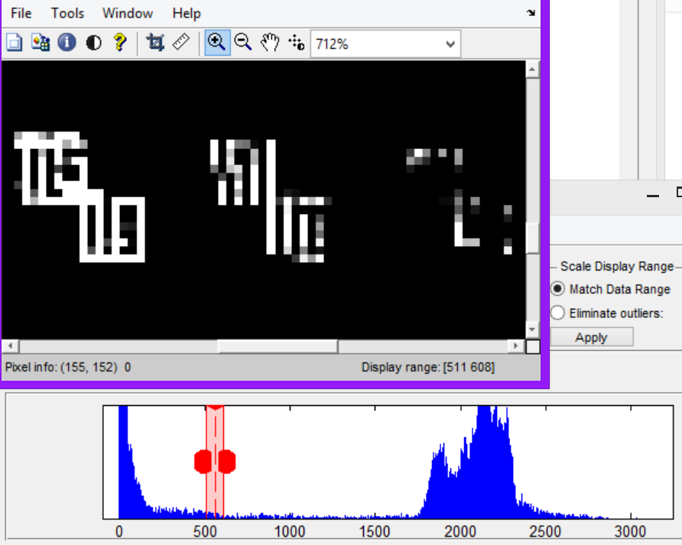 | If selected “Manual”, then change the intensity level and windows to perform HCSR as instructed in the ACR manual
9 | 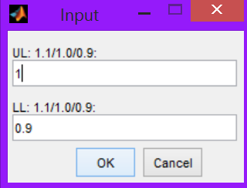 | Enter the HCSR results, if selected “Manual”
10 | 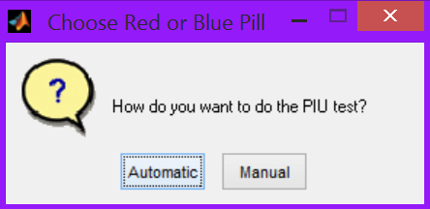 | Automatic PIU (percentage intensity uniformity) test is available.
11 | 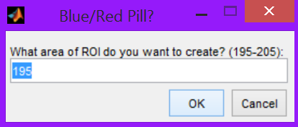 | If selected “Manual”, then choose the ROI area first
12 | 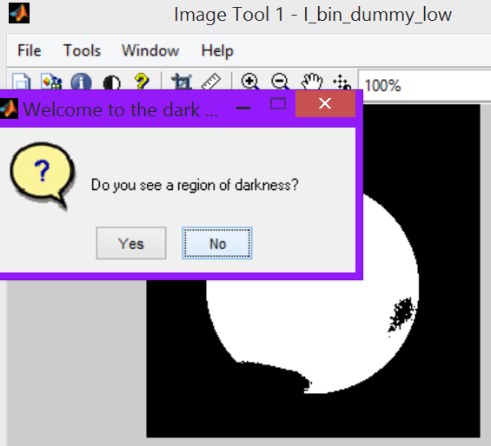 | Follow the prompt window, select “Yes” until dark spot is observed. A window will pops up, user can use a cross curser to click at the ROI to generate a 1cm² ROI. Later do the same to the bright spot
13 | 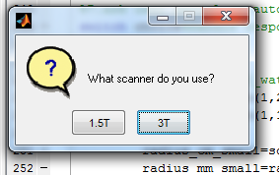 | If the image does not have the field strength DICOM tag, user need to select the field strength manually. Otherwise, it can be done automatically
14 | 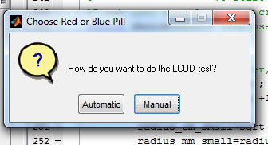 | LCOD (low contrast object detectability) test is not available, so click “Manual” here
15 | 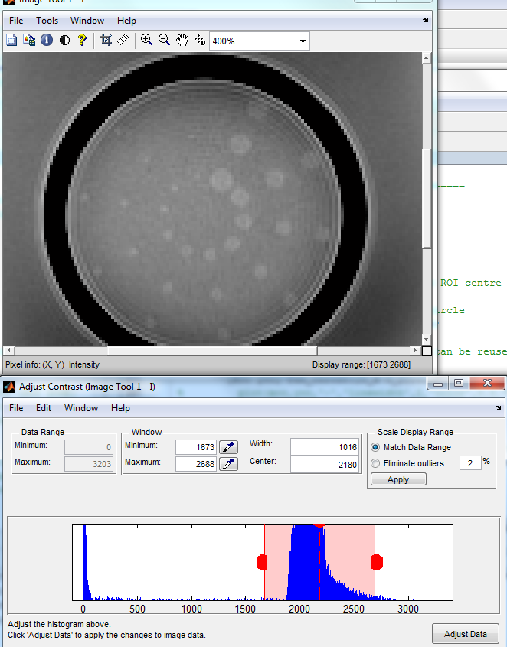 | When you do the LCOD test manually, change the image intensity level and window and observe how many high intensity spokes with the same size you can see. You have to be able to see all three spokes with the same size to say you can detect spokes of that size.
16 | 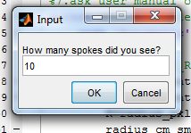 | Close the image window and this window pops up. Enter the number of spokes (1-10) you can see.
After T1 image QA, T2 image QA will take place, so follow the same procedure
17 | 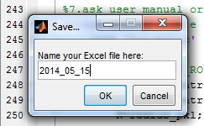 | Name the Excel file name
18 | 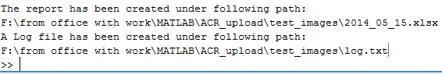 | The path of the saved Excel file and log file is shown in cmd window

